Implementing date system call:

1. The changes have been made to the following files for implementing date system call:
a. user.h
b. usys.S
c. syscall.h
d. syscall.c
e. sysproc.c

user.h:
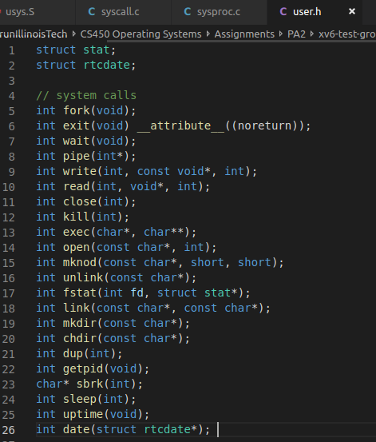
A new function is declared in line 26 for date system call which takes input, a pointer to struct rtcdate and gives an int value as output. This user.h header file is included in the user level program which wants to use system calls.

Please check “user_header_file.txt” in ./diff/ folder

usys.S:
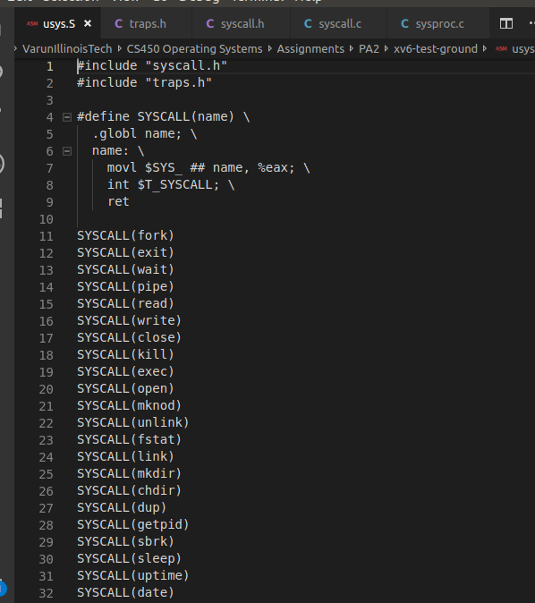
A new entry is added at line 32 in usys.S. This line will be executed when date system call is called from the user level program. The macro defined in line 4 takes care of moving correct system call value to the eax register and then raising the interrupt giving over the control to OS to execute the system call and return the value.
The value of SYS_date to be stored in eax is defined in “syscall.h” header file.

Please check “usys.txt” in ./diff/ folder

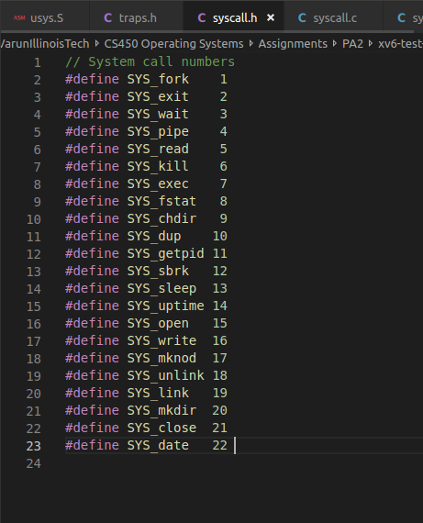
syscall.h:

The system call date is given a number 22. This will be used later on to correctly identify the function to be run in kernel mode.

Please check “syscall_header.txt” in ./diff/ folder

syscall.c:
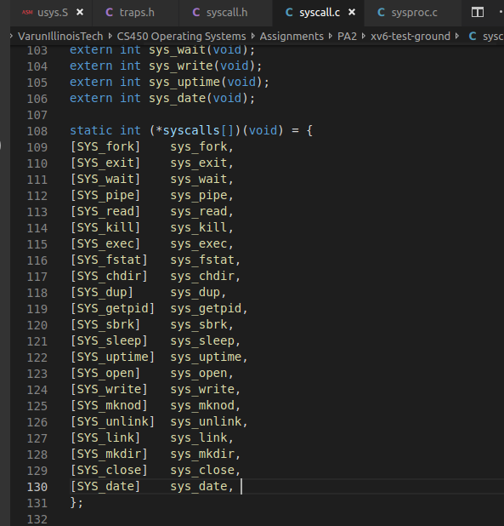
sys_date function is declared as extern here in this file in line 106 and also added in the function pointers array in line 130. This declaration is necessary since the file in which sys_date is defined is linked to this file during linking time.

Please check “syscall.txt” in ./diff/ folder

sysproc.c:
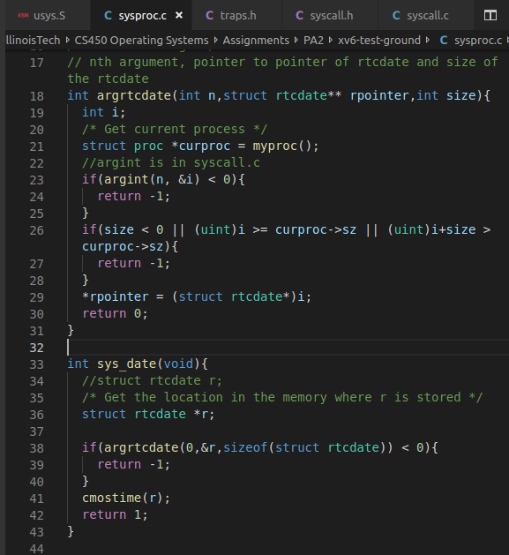
Two new function are added in sysproc.c.

sys_date: This function is finally called from syscall() function of syscall.c. This function has a pointer of type struct rtcdate. The first step in this function is to get the memory location of the struct rtcdate variable passed by the user level program. This is done by argrtcdate() function in line 18. Then this function calls cmostime() which gives the current UTC time. Then it returns 1 after successful completion.

argrtcdate: In this function we first get the pointer to struct proc and then get the pointer to the variable shared by user level program for that in line 29. There are also checks to see if we are looking only in the current process’s memory in line 26. Here in this function the variable “r” shared by the user level program is filled up with utc time and then returned.

Please check “sysproc.txt” in ./diff/ folder

A program date.c has been implemented that calls date() system call and prints out UTC date and time in hr:min:sec mm-dd-yyyy format. The code is here:
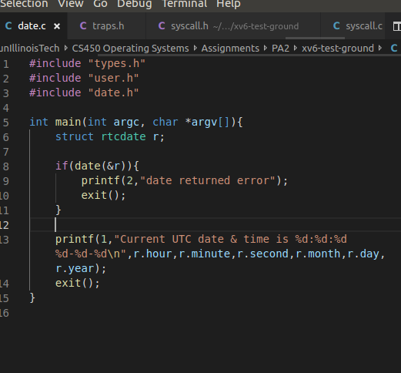

The code is very simple. It just
calls the date function. If it returns error, the error message will be printed and program exits. If not the UTC time will be printed in hour:min:sec mm-dd-yyyy format.

Also, following changes were made in the Makefile to accommodate for user level programs date.c and date_testing.c.
1. _date & _date_testing are added under UPROGS list.
2. date.c and date_testing.c are added in the EXTRA section.
Please check “Makefile.txt” in ./diff/ folder
